Overview
Package: OMA
Authors:
- Tuomas Borman [aut, cre]
- Leo Lahti [aut]
- Felix GM Ernst [aut]
- and others (see the full list of contributors) [ctb]
Compiled: 2025-09-06
Package version: 0.98.44
R version: R version 4.5.1 (2025-06-13)
BioC version: 3.22
License: CC BY-NC-SA 4.0
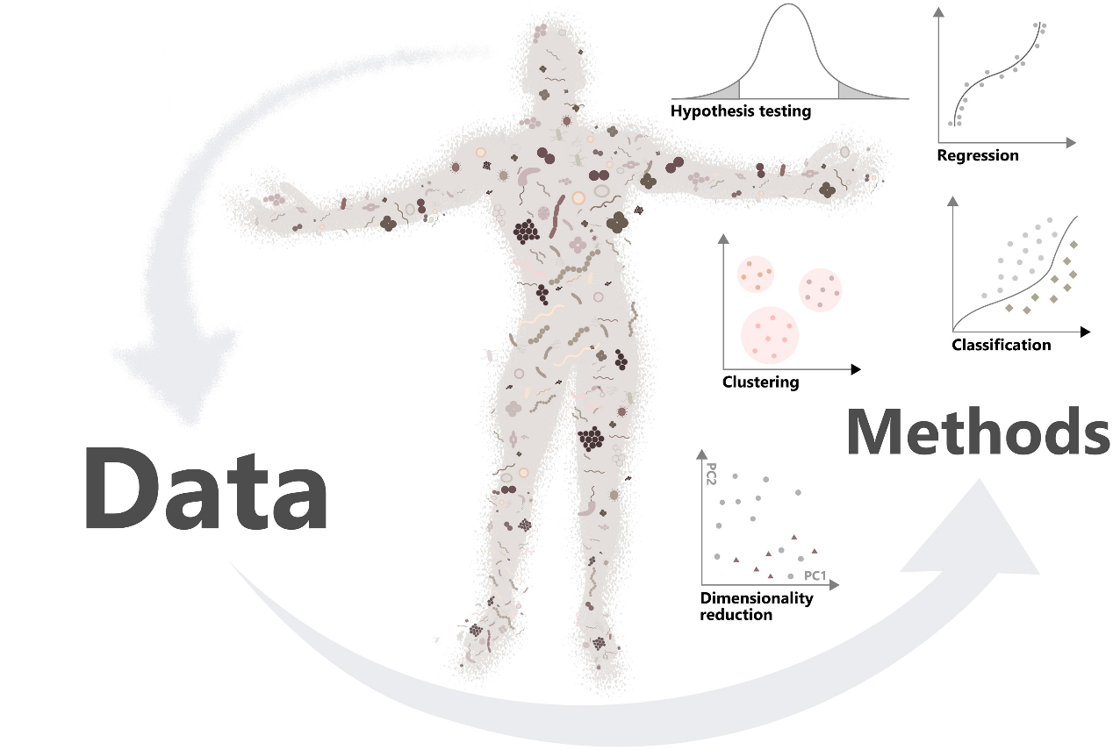
Welcome
Important!
This is a development version of the Orchestrating Microbiome Analysis with Bioconductor (Tuomas Borman et al. 2024) book from the the miaverse.
Tuomas Borman, Leo Lahti, Sudarshan Shetty, Felix M Ernst, et al. 2024. Orchestrating Microbiome Analysis with Bioconductor [Beta Version]. microbiome.github.io/oma/.
You are reading the online book, Orchestrating Microbiome Analysis with Bioconductor (Tuomas Borman et al. 2024), where we walk through common strategies and workflows in microbiome data science.
The book shows through concrete examples how you can take advantage of the latest developments in R/Bioconductor for the manipulation, analysis, and reproducible reporting of hierarchical and heterogeneous microbiome profiling data sets. The book was borne out of necessity, while updating microbiome analysis tools to work with Bioconductor classes that provide support for multi-modal data collections. Many of these techniques are generic and widely applicable in other contexts as well.
This work has been heavily influenced by other similar resources, in particular the Orchestrating Single-Cell Analysis with Bioconductor (Amezquita et al. 2020), phyloseq tutorials (Callahan et al. 2016) and microbiome tutorials (Shetty and Lahti 2019). This book extends these resources to teach the grammar of Bioconductor workflows in the context of microbiome data science. As such, it supports the adoption of general skills in the analysis of large, hierarchical, and multi-modal data collections. We focus on microbiome analysis tools, including entirely new, partially updated as well as previously established methods.
Amezquita, Robert, Aaron Lun, Stephanie Hicks, and Raphael Gottardo. 2020. Orchestrating Single-Cell Analysis with Bioconductor. Bioconductor. https://bioconductor.org/books/release/OSCA/.
Callahan, Ben J., Kris Sankaran, Julia A. Fukuyama, Paul J. McMurdie, and Susan P. Holmes. 2016. “Bioconductor Workflow for Microbiome Data Analysis: From Raw Reads to Community Analyses [Version 2; Peer Review: 3 Approved].” F1000Research 5: 1492. https://doi.org/10.12688/f1000research.8986.2.
Shetty, Sudarshan, and Leo Lahti. 2019. “Microbiome Data Science.” Journal of Biosciences 44: 115. https://doi.org/10.1007/s12038-019-9930-2.
Serizay, Jacques. 2023. BiocBook: Write, Publish and Maintain Versioned Quarto Books with Bioconductor. https://github.com/js2264/BiocBook.
This online resource and its associated ecosystem of microbiome data science tools are a result of a community-driven development process, and welcoming new contributors. Several individuals have contributed methods, workflows and improvements as acknowledged in the Introduction. You can find more information on how to find us online and join the developer community through the project homepage at microbiome.github.io. This online resource has been written in Quarto with the BiocBook package (Serizay 2023). The material is free to use with the Creative Commons Attribution-NonCommercial 3.0 License.
We assume that the reader is already familiar with R programming. For references and tips on introductory material for R and Bioconductor, see 30 Resources. In this book, we start by introducing the material and link to further resources for learning R and Bioconductor. We describe the key data infrastructure, the TreeSummarizedExperiment class that provides a container for microbiome data, and how to get started by loading microbiome data set in the context of this new framework. After becoming familiar with data containers and data importing, the book covers the common steps in microbiome data analysis, beginning with the most common steps and progressing to more specialized methods in subsequent sections. Workflows, provides case studies for the various datasets used throughout the book. For hands-on practice, the Training section provides comprehensive training resources. Finally, Appendix, links to further resources and acknowledgments.
Building OMA book
This book is automatically built to ensure that all code examples are functional. See E.2 Session info for details.
In addition to accessing this book online, you can copy and paste the executable code examples to run on your local computer. For package installation instructions, refer to 2.2 Package ecosystem. You can also build and view the entire book locally by following the steps provided here, or use Docker image E.1 Docker image.

